BEM CDR Log Ingestion

AppDynamics Log Analytics

Provided log file locations, format of Call Data Records as well as KPI’s .

Log File locations:

SMS -  /data/cdrs/pending/ZA/sms/\*.GNV

MMS - /opt/bem/logs/cdrs/pending/\*.GNV

– how they differ from regular log files is structured format.

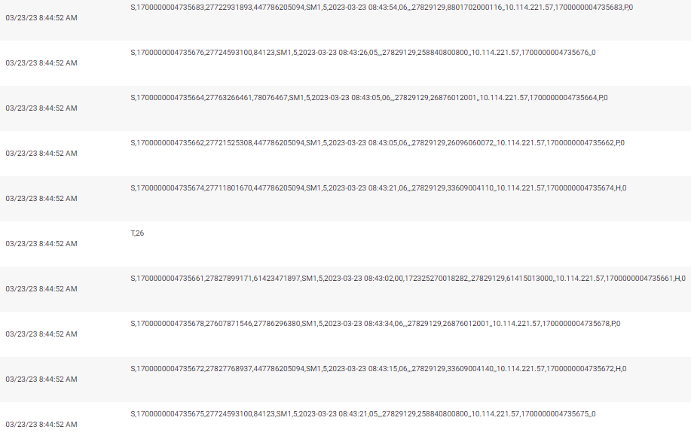

Testing started in DEV – MTO server identified, agent installed and CDR records copied to test.

Mock Dashboard created on the 4th of October – Very close to the end product.

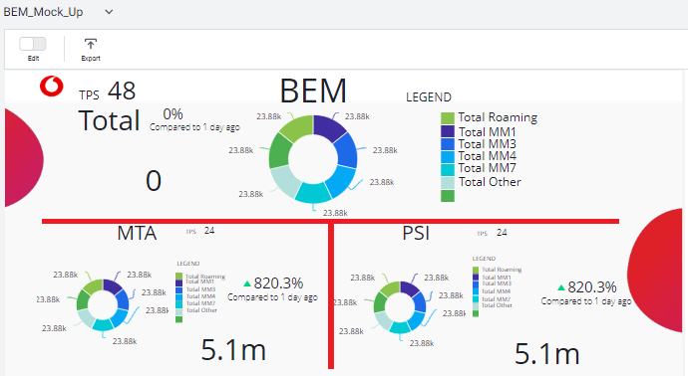

Installed Analytics agents on 8 Production Servers

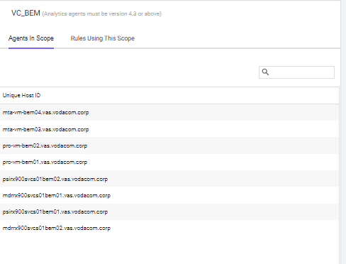

4 servers in use at any time - Redundancy

Only 8 days of history in Analytics itself, but from there Metrics can be generated which are stored for 1 year.

Created metrics relevant to KPI’s indicated, but also discussed using certain criteria for Analytics Reference, eg. Originating and Destination MSISDN, to identify the different WASP customers and the number of transactions for each, not turned into metrics so only 8 days of history.

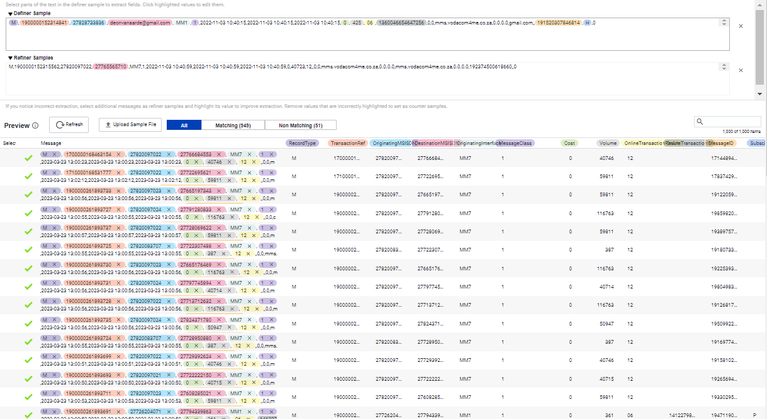

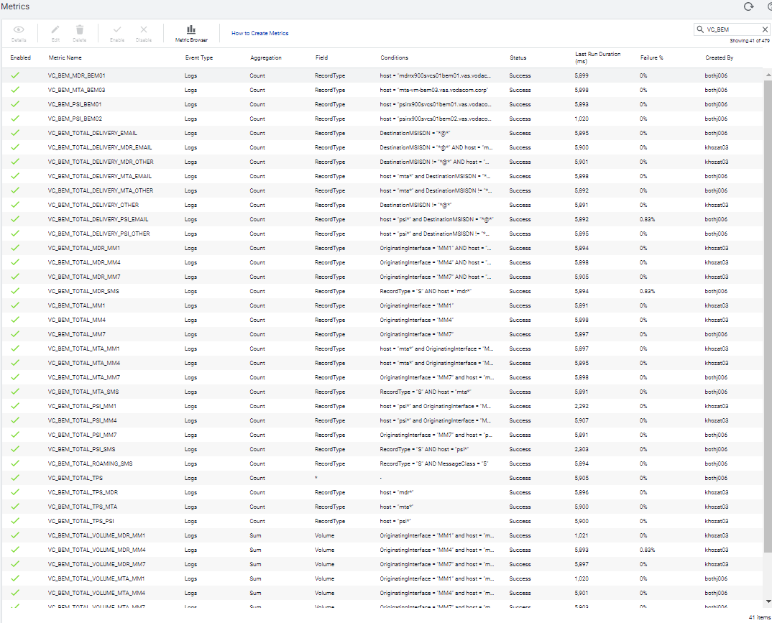

Created Production Dashboard 03rd November and pinned Metrics to it.

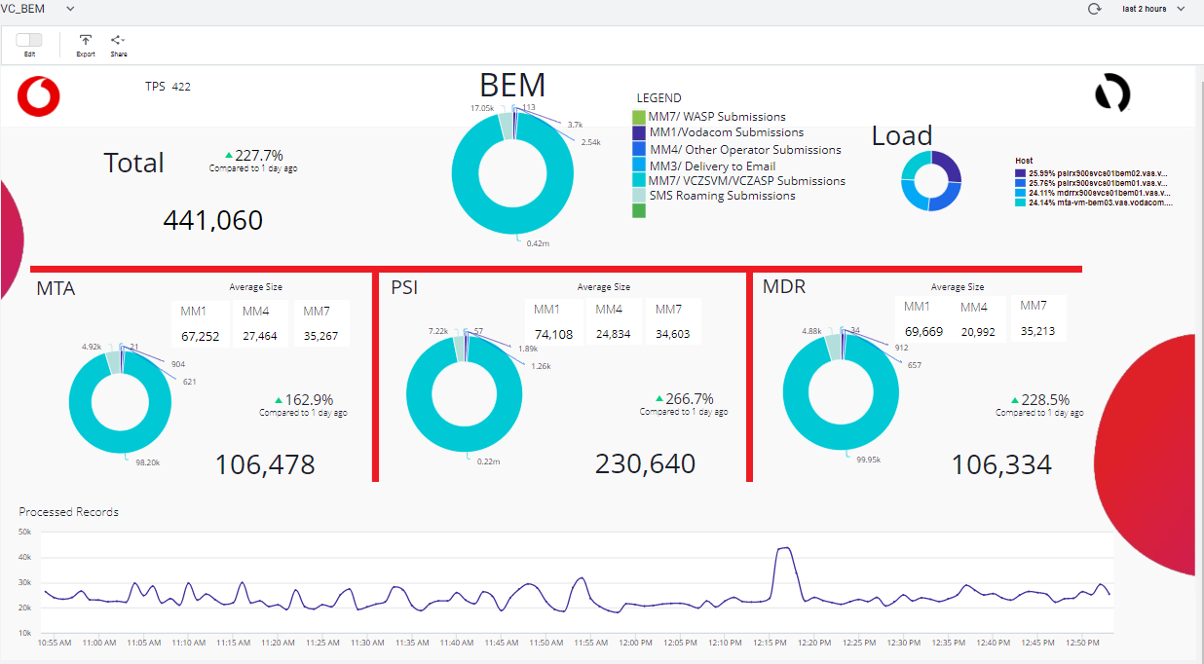

Newer requirements included indication of load on each active server, done by adding load Pie Chart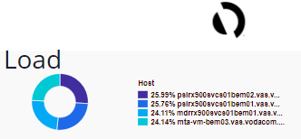

Not all sites were considered in original KPI’s, created metrics for MDR site, still not displaying all as no sufficient traffic has hit PRO site.

Going forward – Install Machine agents to monitor Log Analytics agent and BEM application processes.

Understanding of what constitutes failure, what has gone wrong in the past that took the system down, when to trigger alerts and who to send the alerts to?

OTR – Success rate

Baseline alerting on TPS

Utilizing the Analytics function of AppDynamics for improvement of interrogation and problem solving.

